Research Push Notification API

Christine Hodges

Rasmussen College

Author Note

This paper is being submitted on June 14th, 2018 for Darice Corey CIS4655 Advanced Mobile Web Application Development course.

**Requesting permission**

The Permissions API provides a consistent programmatic way to query the status of API permissions attributed to the current context — for example whether permission to use the API is granted or denied, and whether the user will be asked whether permission should be granted for an API. The permissions property has been made available on the [Navigator](https://developer.mozilla.org/en-US/docs/Web/API/Navigator) object, both in the standard browsing context and the worker context ([WorkerNavigator](https://developer.mozilla.org/en-US/docs/Web/API/WorkerNavigator" \o "The WorkerNavigator interface represents a subset of the Navigator interface allowed to be accessed from a Worker. Such an object is initialized for each worker and is available via the WorkerGlobalScope.navigator property obtained by calling window.self.navigator.) — so permission checks are available inside workers), and returns a [Permissions](https://developer.mozilla.org/en-US/docs/Web/API/Permissions) object that provides access to the Permissions API functionality. Once you have this object you can then perform permission-related tasks, for example querying a permission using the [Permissions.query()](https://developer.mozilla.org/en-US/docs/Web/API/Permissions/query" \o "The Permissions.query() method of the Permissions interface returns the state of a user permission on the global scope.) method to return a promise that resolves with the [PermissionStatus](https://developer.mozilla.org/en-US/docs/Web/API/PermissionStatus" \o "The PermissionStatus interface of the Permissions API provides the state of an object and an event handler for monitoring changes to said state.) for a specific API (Mozilla, 2018).

**Creating notifications**

The Notification interface of the Notifications API is used to configure and display desktop notifications to the user. Notification()Creates a new instance of the Notification object.

**Closing notifications and notification events**

The onclose property of the Notification interface specifies an event listener to receive close events. These events occur when a Notification is closed.

**Browser compatibility**

Mozilla has an incredible diagram that shows different API’s and browser compatibility. This table is shown on the feature and what browser will work for both desktop and mobile. Here is an image from the table, retrieved from Mozilla: <https://developer.mozilla.org/en-US/docs/Web/API/notification>

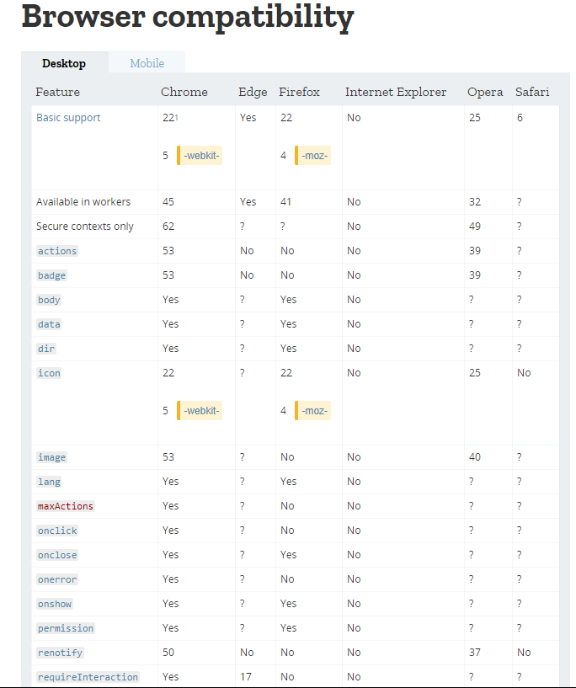

**References:**

Mozilla. 2018. Permissions API. Retrieved from: https://developer.mozilla.org/en-   
 US/docs/Web/API/Permissions_API

Mozilla. 2018. Browser Compatibility. Retrieved from: https://developer.mozilla.org/en-  
 US/docs/Web/API/notification